What is AWS Lambda?

AWS Lambda is a serverless computing service from Amazon Web Services that lets you run code without creating or managing servers.

You just:
- Upload your code
- Set a trigger (event)
- Lambda runs the code automatically

You only pay for the time your code runs.

Simple Definition

AWS Lambda = Run code automatically when an event happens, without managing servers.

Example (Real Life AWS Example)

Imagine this flow:

1️⃣ User uploads a file to Amazon S3
2️⃣ S3 triggers AWS Lambda
3️⃣ Lambda processes the file (resize image, log data, etc.)

Flow:

User Upload File
↓
Amazon S3
↓
Trigger Event
↓
AWS Lambda
↓
Process File

Key Features

✔ No server management
✔ Automatic scaling
✔ Pay only when code runs
✔ Supports multiple languages
- Python
- Node.js
- Java
- Go
- .NET

Before Starting (One-Time Setup)

Step 1: Login to AWS
- Go to AWS Console
- Search Lambda in services
- Click Create Function

Step 2: Select Creation Method
Choose:
Author from Scratch
Options explanation:
Option | Meaning
Function Name | Name of your Lambda function
Runtime | Programming language (Python recommended)
Architecture | Processor type (x86_64 default)
Permissions | IAM role allowing Lambda to access AWS services
Choose:
Runtime → Python 3.12
Architecture → x86_64
Permissions → Create new role with basic Lambda permissions
Click Create Function
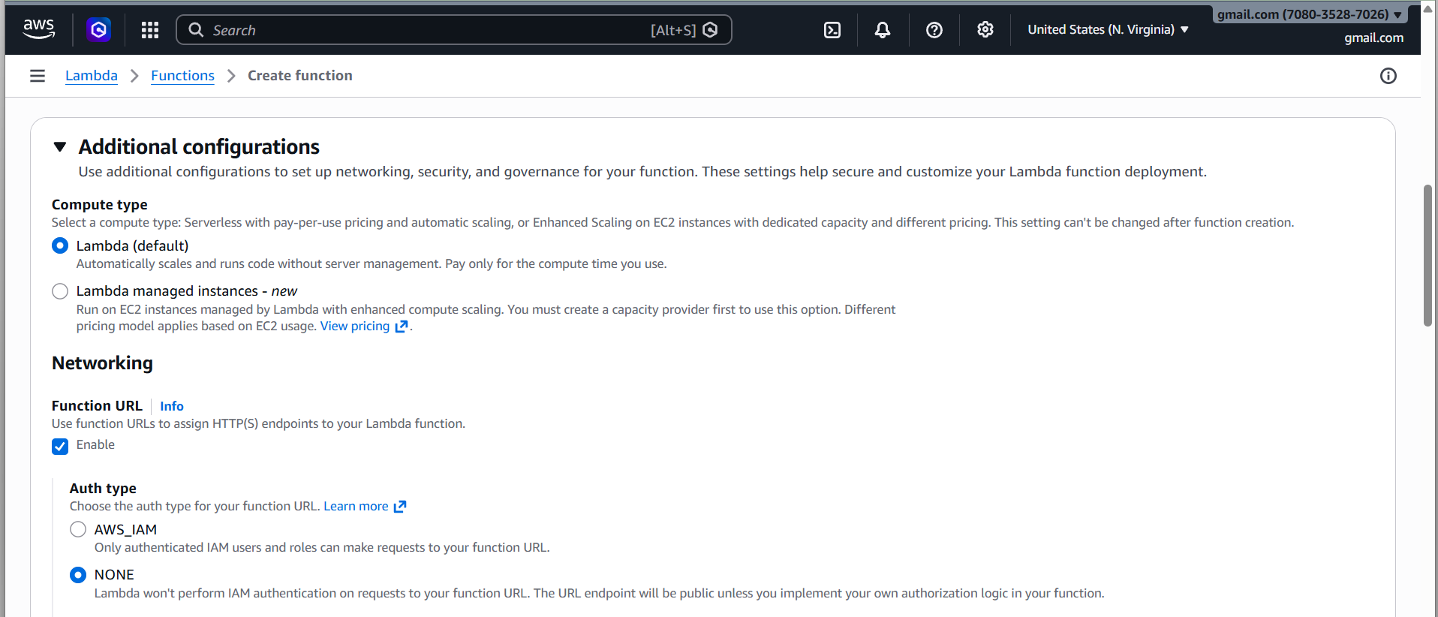
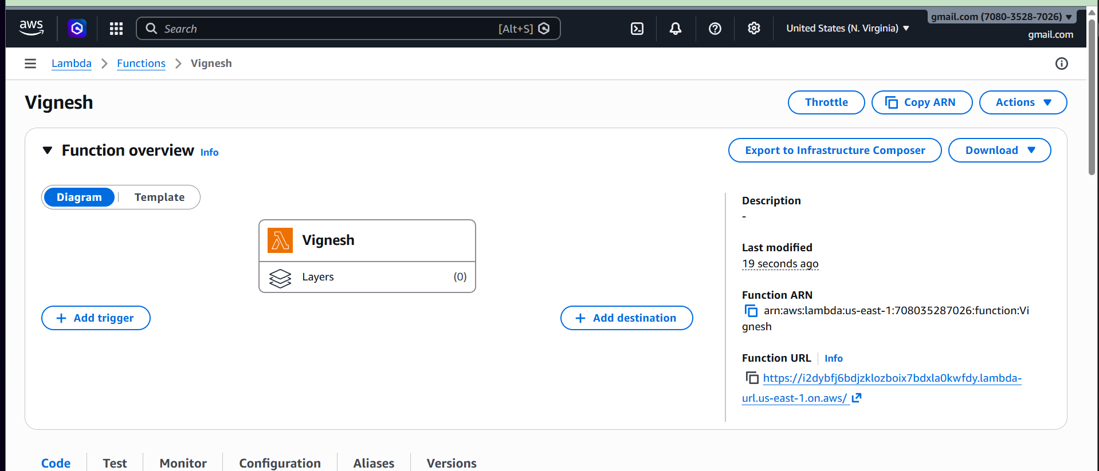
Now we write programs.
Program 1 — Hello World Lambda
Purpose
Basic Lambda execution test.
Code
def lambda_handler(event, context):
message = "Hello from AWS Lambda!"
return {
'statusCode': 200,
'body': message
}

Explanation
Part | Meaning
lambda_handler | Entry point of Lambda
event | Input data passed to Lambda
context | Runtime info (memory, time, request id)
statusCode | HTTP response code
body | Output message

Deploy The Code First (If You Change Code Or Any Updates Deploy First And Test)
And Next Test
Correct Order in AWS Lambda
Whenever you change the code, follow this order:
Update / Paste the Code
Click Deploy
After editing the code, click the Deploy button.
If you don’t deploy, Lambda will still run the old code.
So always remember:
Edit Code → Deploy → Test
Test Execution
- Click Test
- Create test event
- Name → test1
- JSON input:
{
"name": "AWS"
}
Click Test
Output appears in Execution Results
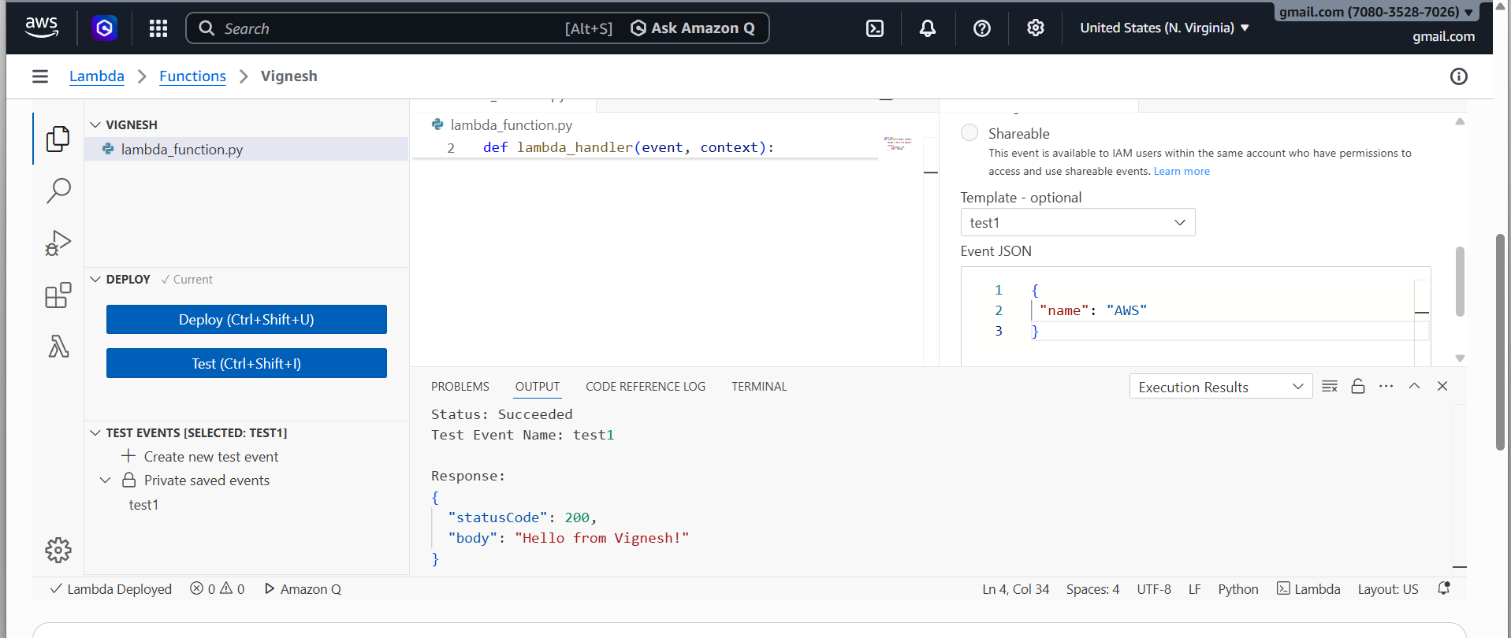
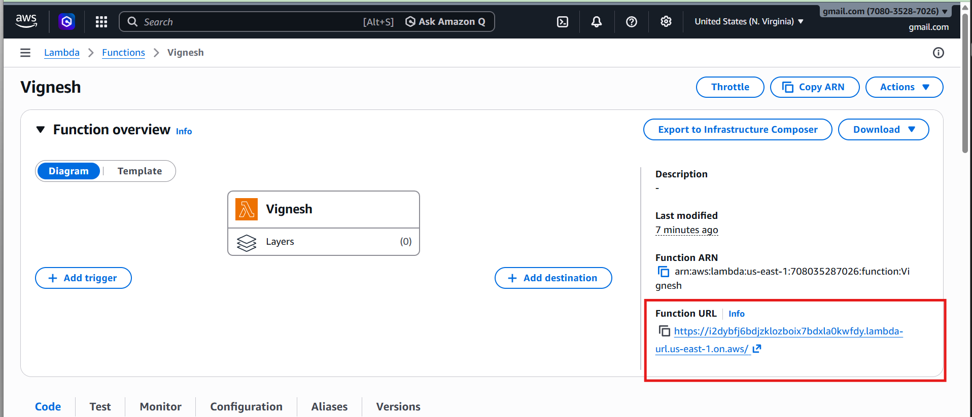

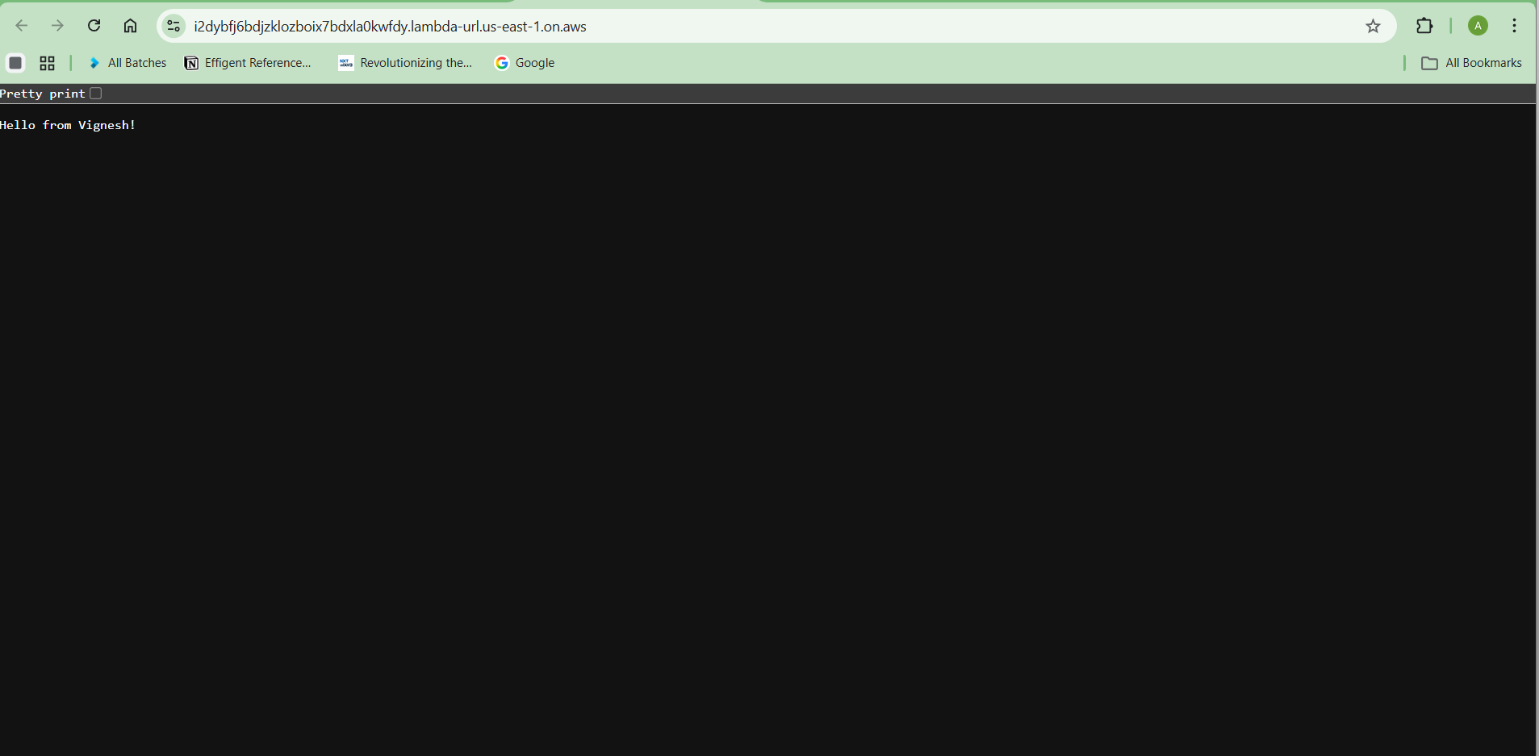

Program 2 — Add Two Numbers
Purpose
Perform arithmetic operations using Lambda.
Code
import json
def lambda_handler(event, context):
num1 = event.get('num1', 0)
num2 = event.get('num2', 0)
result = num1 + num2
return {
"statusCode": 200,
"body": json.dumps(result)
}

Test Event
{}
Output
30

Flow
User Input → Event JSON → Lambda Function → Processing → Output
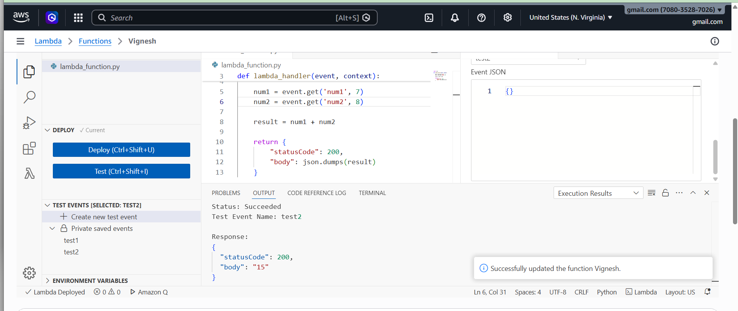

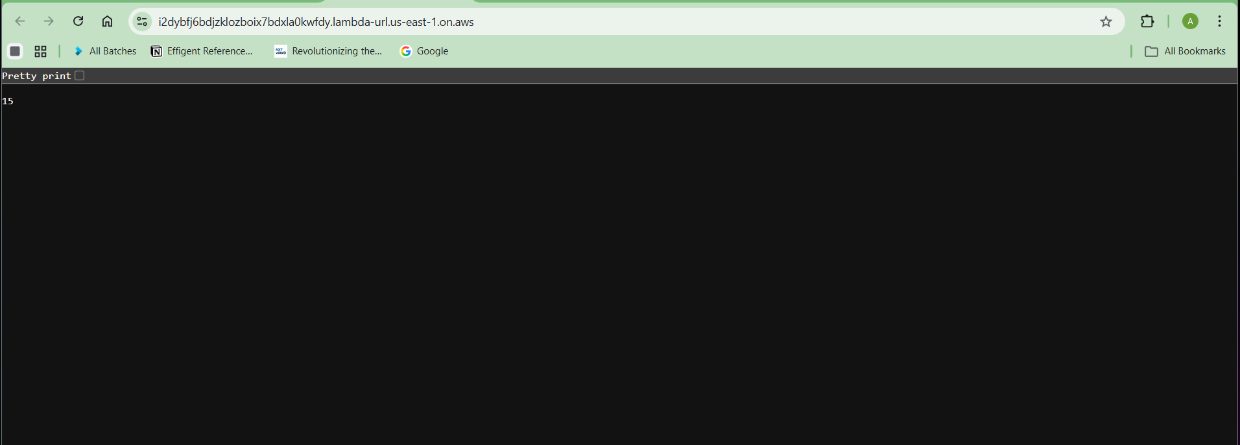

Correct Lambda Execution Flow
Test Event
↓
Event JSON
↓
Lambda receives event
↓
Extract num1 and num2
↓
Add numbers
↓
Return result

Program 3 — S3 File Upload Trigger Lambda
Purpose
Automatically execute Lambda when a file uploads to S3.

Architecture Flow
User → Upload file → S3 Bucket → Trigger → Lambda → Process file
Step 1 — Create S3 Bucket
AWS Console
Search S3
Click Create Bucket

Settings:
Option | Value
Bucket Name | lambda-trigger-bucket
Region | Same as Lambda
Block Public Access | Enabled
Click Create Bucket

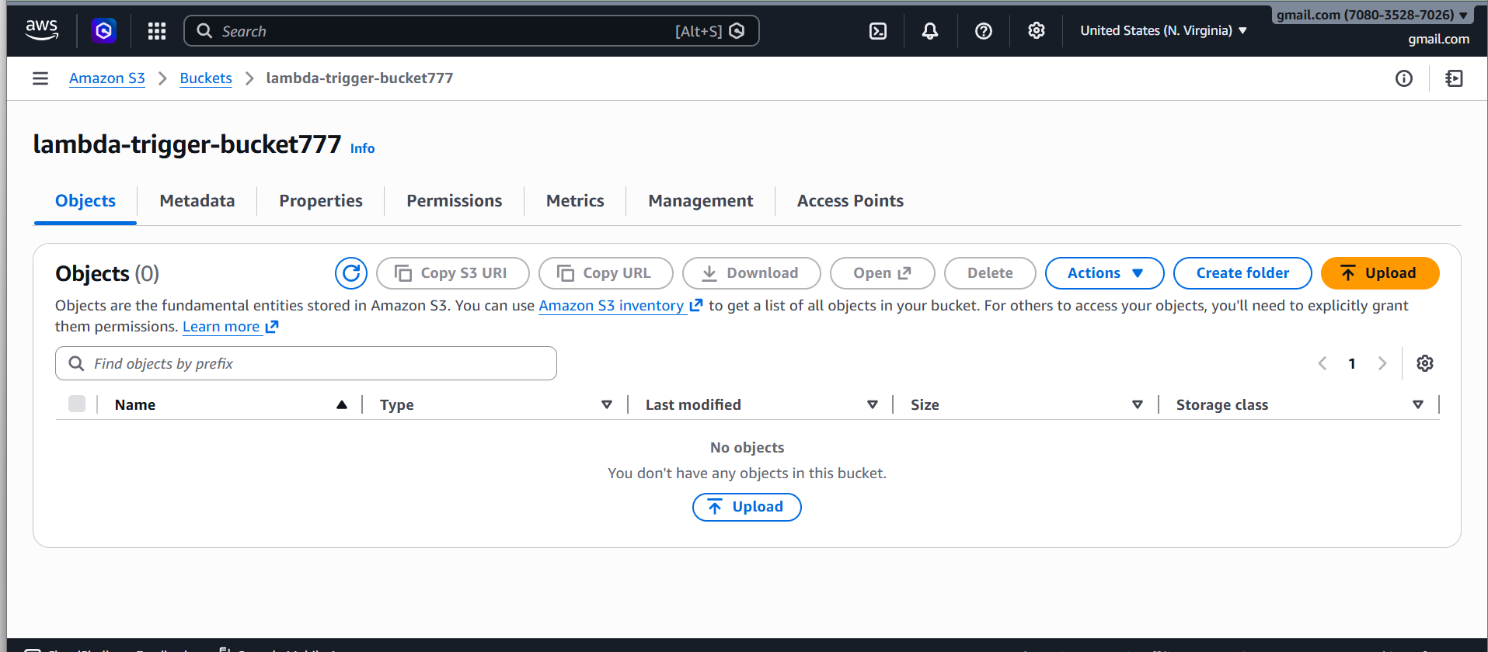
2 step - Add S3 Permission to Lambda
Go to Configuration → Permissions
Add this policy to the Execution Role
AmazonS3ReadOnlyAccess
Steps:
Role name → Click role
Add permissions → Attach policy
Search → AmazonS3ReadOnlyAccess
Attach

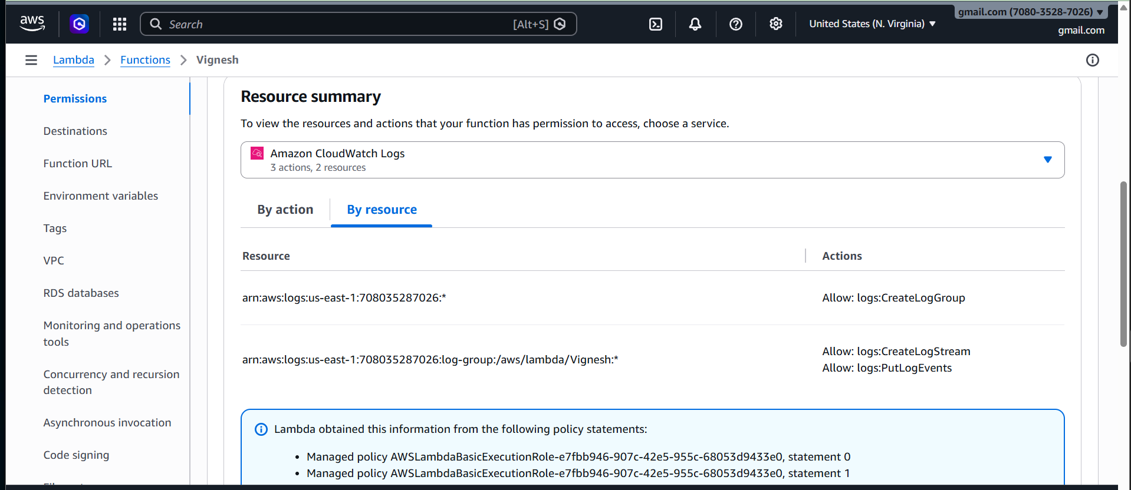

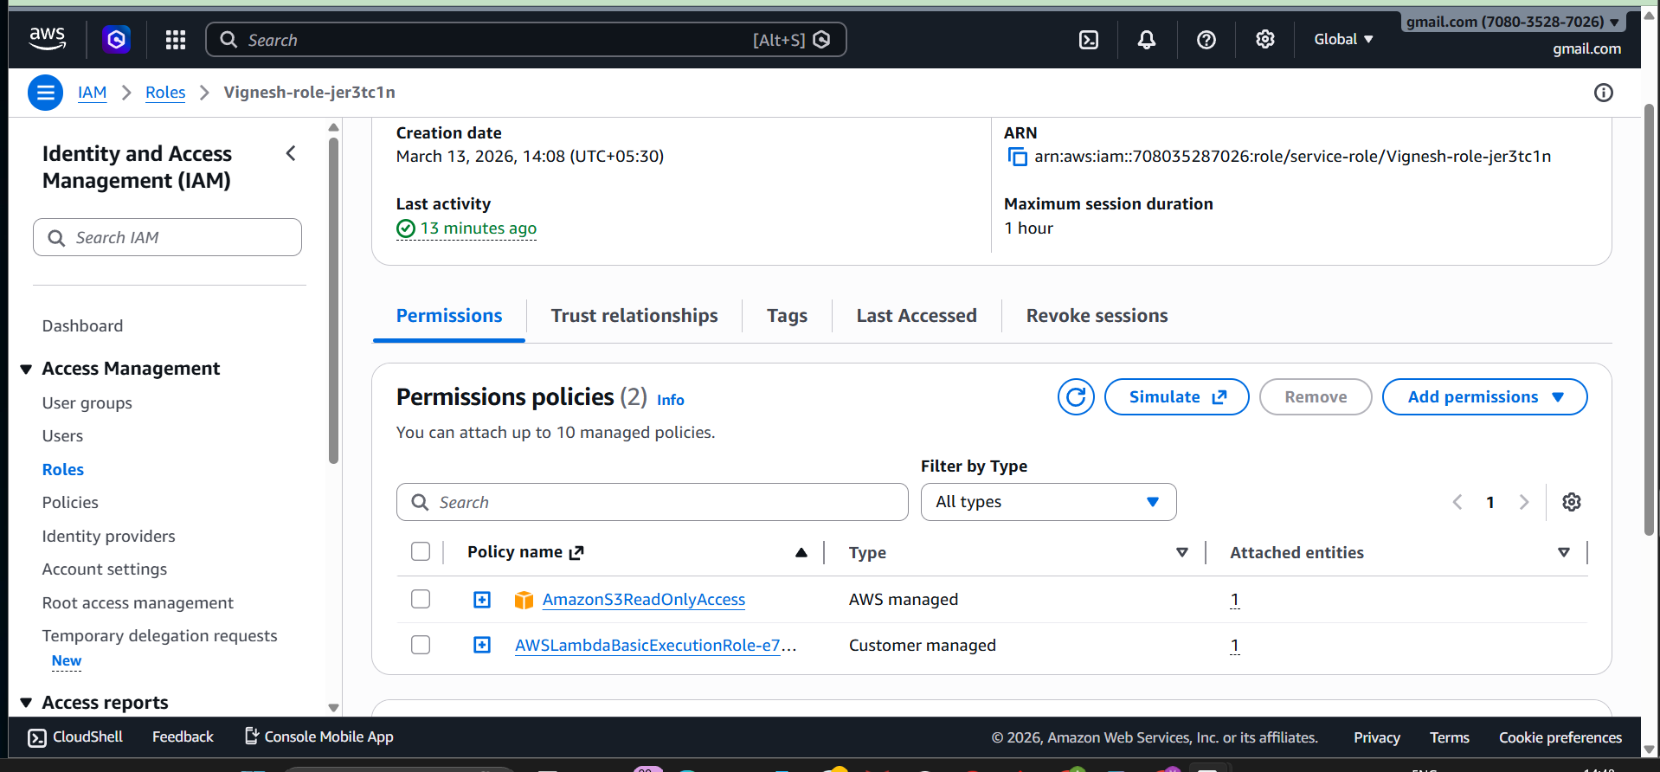
3 step - Updated Lambda Code
import json
def lambda_handler(event, context):
print("Full Event:", json.dumps(event))
try:
bucket = event['Records'][0]['s3']['bucket']['name']
file_key = event['Records'][0]['s3']['object']['key']
print("Bucket Name:", bucket)
print("File Uploaded:", file_key)
message = f"File {file_key} uploaded to {bucket}"
except Exception as e:
print("Error:", str(e))
message = "Event format not matched"
return {
'statusCode': 200,
'body': message
}
4 step - Add S3 Trigger
Go to your Lambda function
Click
Add Trigger
Select:
Source : S3
Fill:
Bucket : lambda-trigger-bucket777
Event type : PUT (Object Created)
Enable: Recursive invocation protection
Click
Add
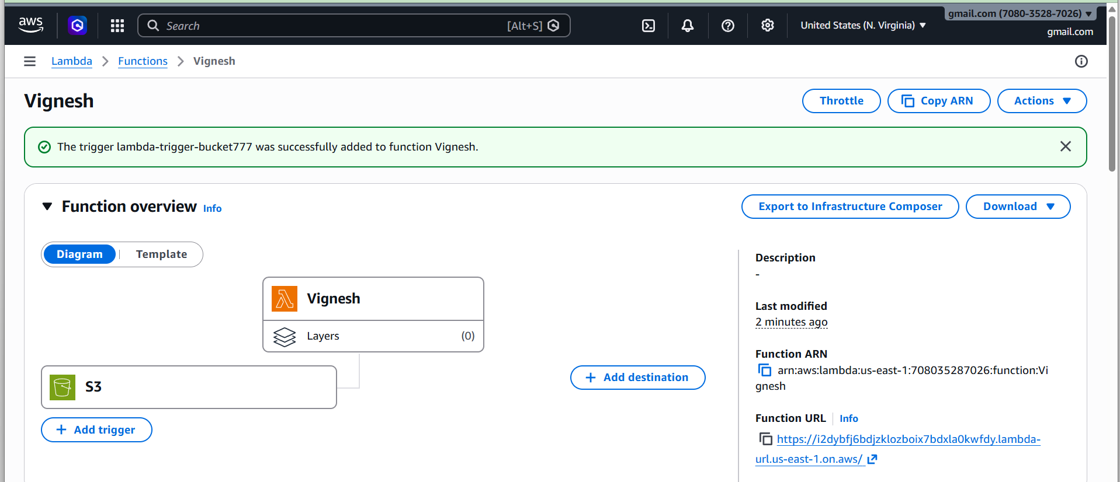

5 step - Upload Test File
Go to S3 bucket
lambda-trigger-bucket777
Upload file
test.txt

6 step - Check Logs
Open:
Lambda → Monitor → View logs in CloudWatch
You should see logs like:
Bucket Name: lambda-trigger-bucket777
File Uploaded: test.txt
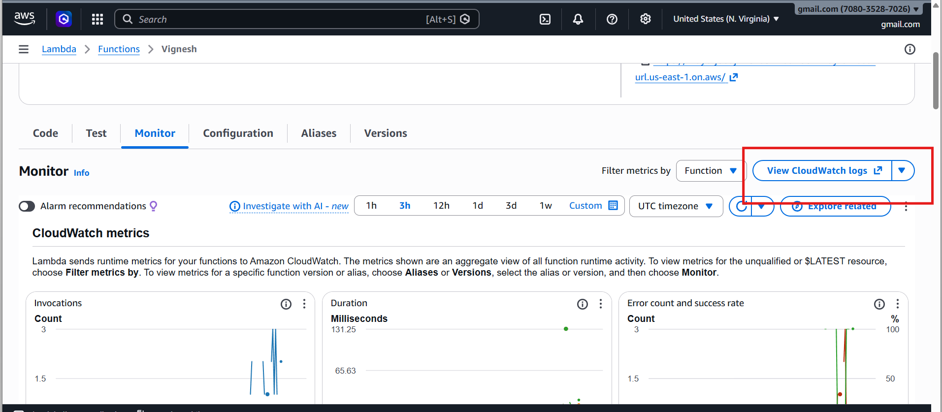

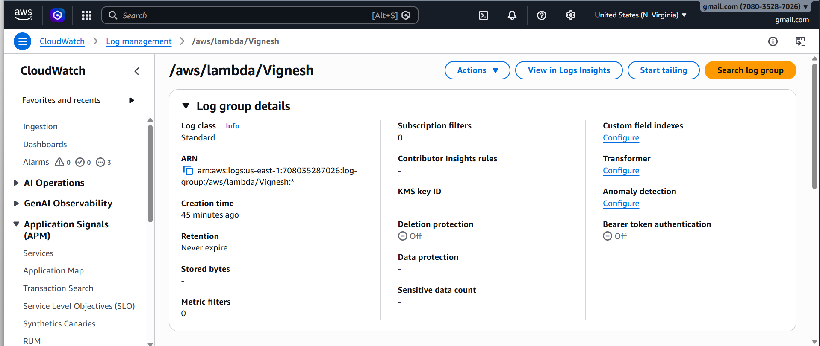

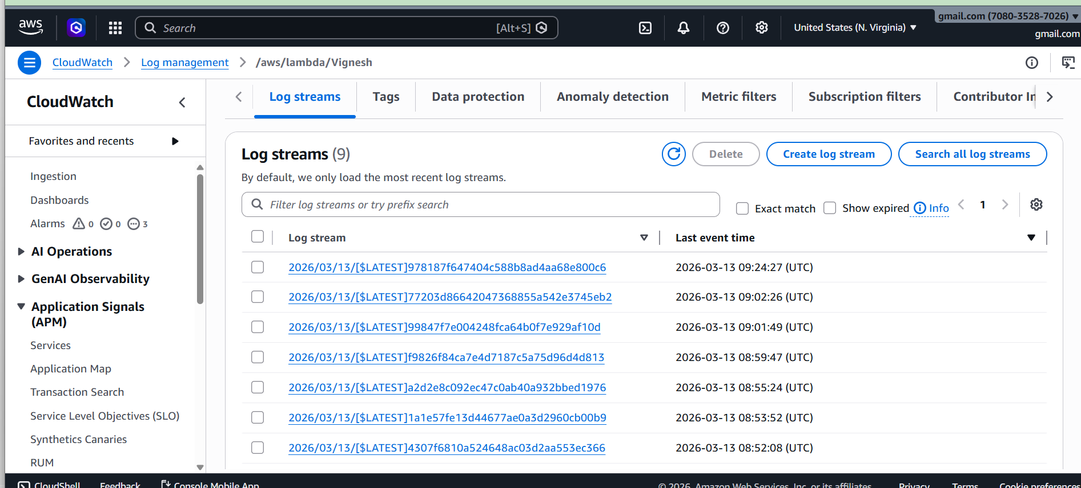
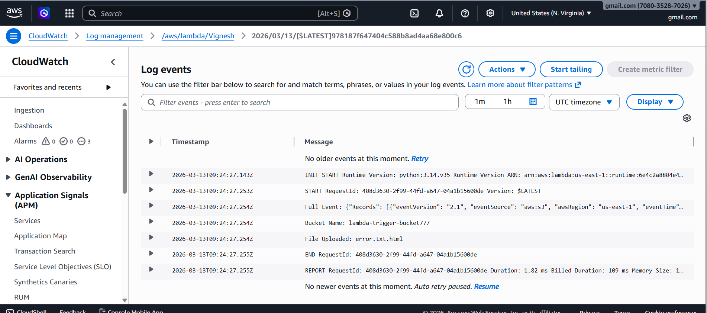

How the Flow Works

User uploads file
↓
S3 Bucket
(lambda-trigger-bucket777)
↓
S3 Event Trigger
↓
Lambda Function
↓
CloudWatch Logs

Program 4 — API Gateway + Lambda
Purpose
Create REST API using Lambda.

Lambda Code
import json
def lambda_handler(event, context):
name = "Guest"
if event.get("queryStringParameters"):
name = event["queryStringParameters"].get("name", "Guest")
message = "Hello " + name
return {
"statusCode": 200,
"body": json.dumps(message)
}
Steps
- Create Lambda
- Go to Add Trigger
- Select API Gateway
Options:
Option | Value
API Type | HTTP API
Security | Open
Click Add
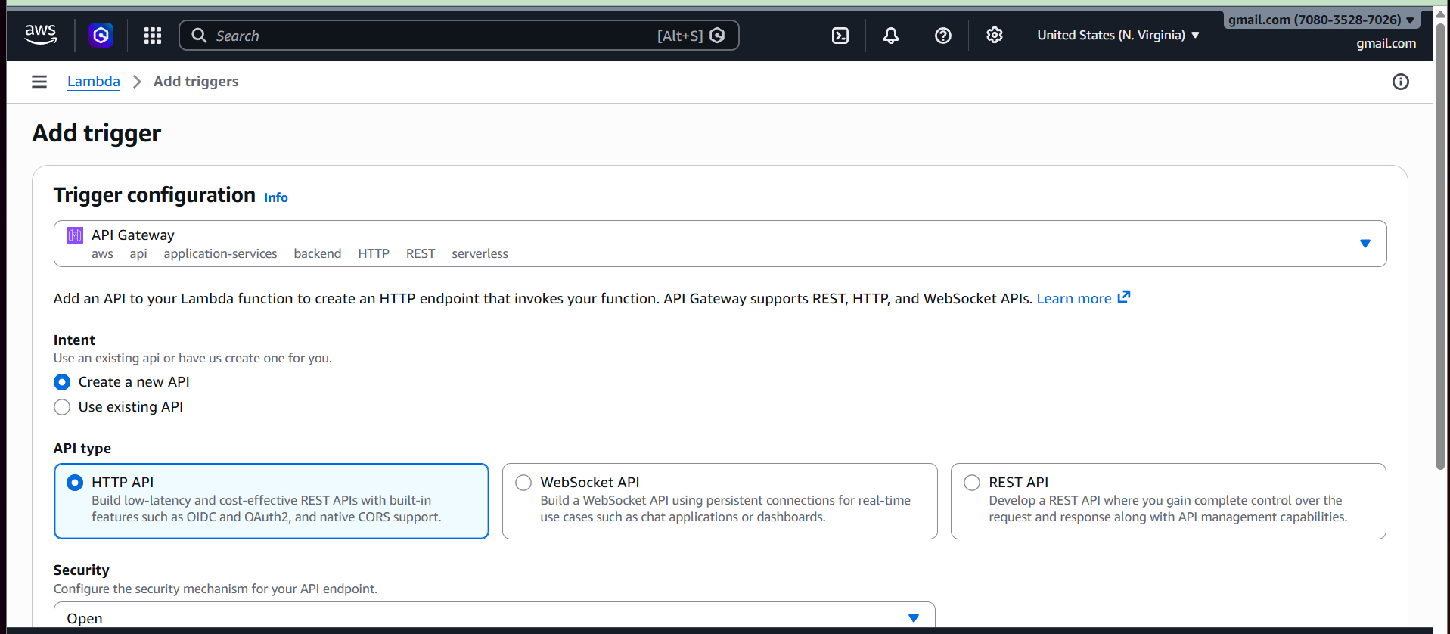

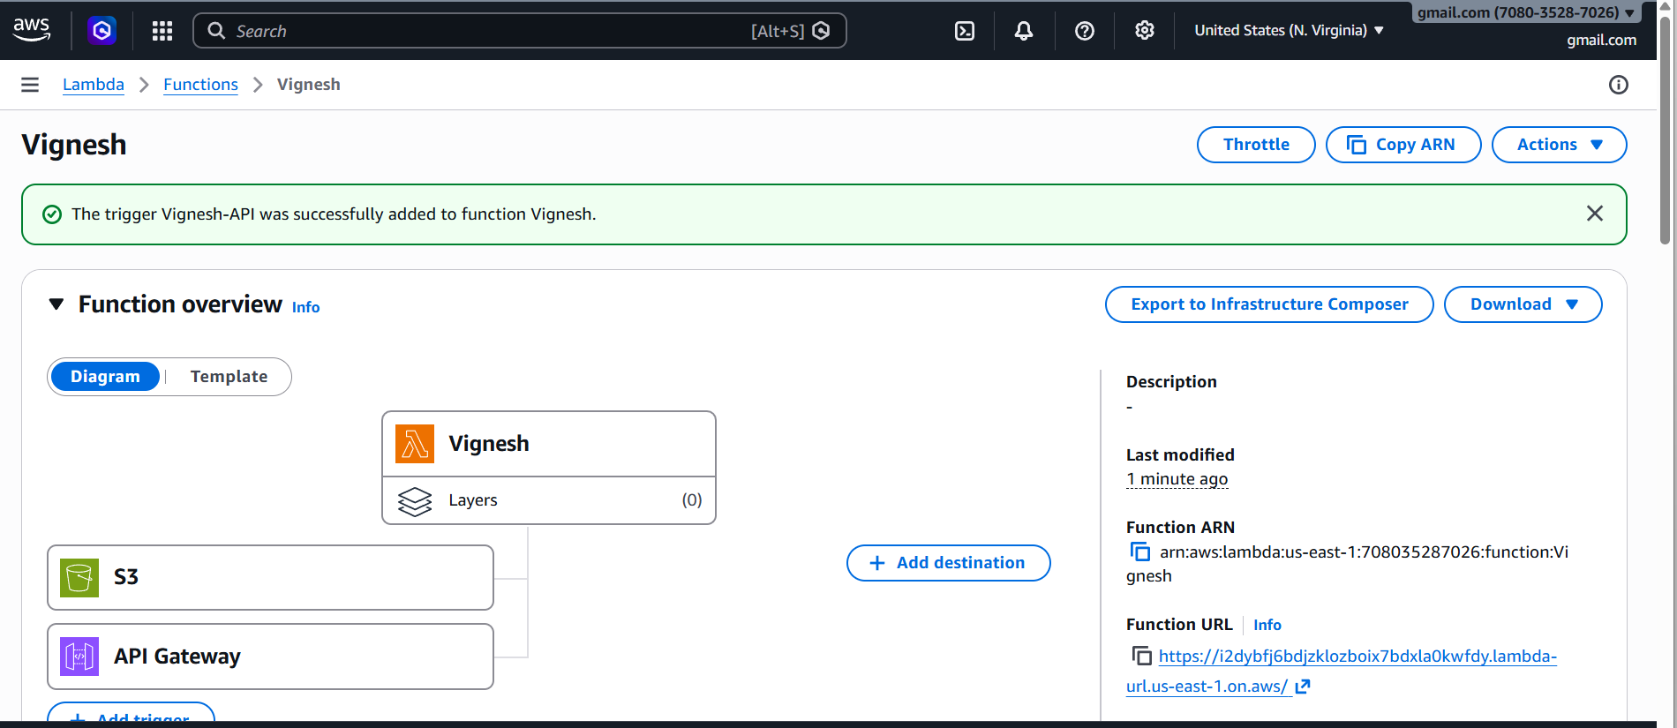
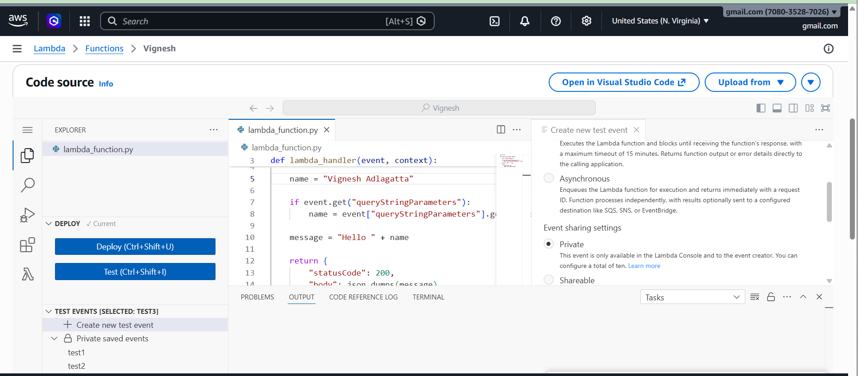
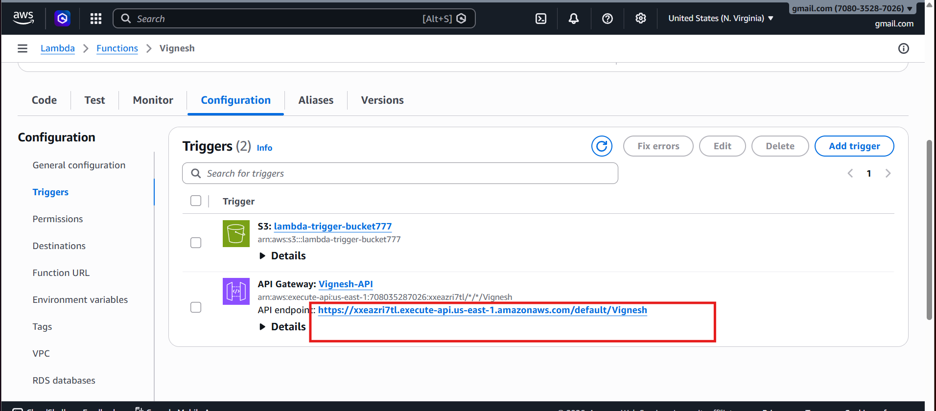
OR
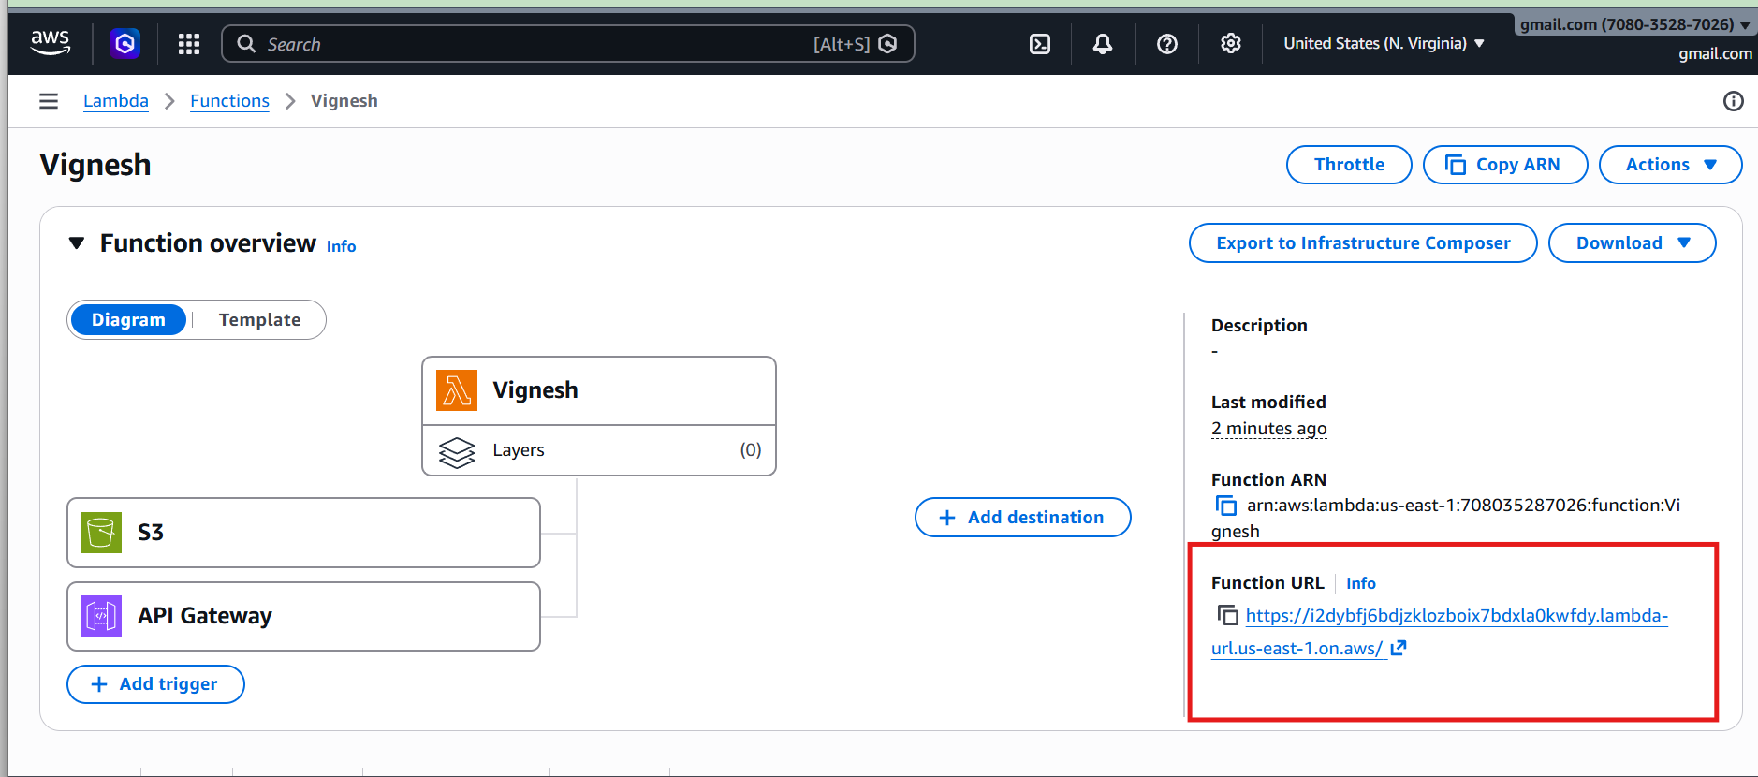

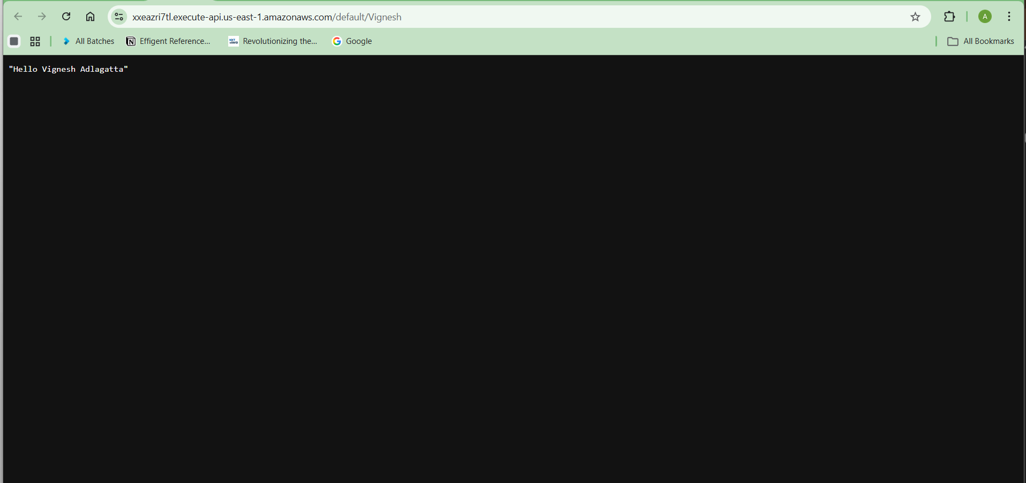

Test
Open generated URL:
https://abc123.execute-api.region.amazonaws.com?name=Vignesh
Output:
Hello Vignesh Adlagatta

Architecture
Client
↓
API Gateway
↓
Lambda
↓
Response

5) AWS Lambda to Launch EC2 Instances
Use AWS Lambda to automatically create EC2 instances.
Architecture flow:
Lambda Function
↓
Boto3 (AWS SDK)
↓
EC2 RunInstances API
↓
EC2 Instances Created

Prerequisites
Before starting, make sure you have:
- AWS account
- EC2 service access
- Lambda service access
- IAM permissions

Step 1 — Find Correct AMI ID
- Open AWS Console
- Go to EC2
- Click Launch Instance
- Select Amazon Linux 2
- Copy the AMI ID
Example (Mumbai region):
ami-03bb6d83c60fc5f7c
Every region has a different AMI ID.

Step 2 — Create Key Pair (Optional but Recommended)
- Go to EC2 Dashboard
- Click Key Pairs
- Click Create Key Pair
Fill details:
Name: devops
Type: RSA
Format: .pem
Click Create
File downloaded:
devops.pem
This is used for SSH login to EC2.

Step 3 — Create IAM Role for Lambda
Lambda must have permission to create EC2 instances.
- Go to IAM
- Click Roles
- Click Create Role
- Select:
AWS Service → Lambda
Attach policy:
AmazonEC2FullAccess
Role name:
LambdaEC2Role
Click Create Role.

Step 5 — Add Python Code
Replace the default code with this:
import boto3
ec2 = boto3.resource('ec2', region_name='ap-south-1')
def lambda_handler(event, context):
instances = ec2.create_instances(
ImageId='ami-03bb6d83c60fc5f7c',
MinCount=5,
MaxCount=5,
InstanceType='t2.micro',
KeyName='devops'
)
print("Instances launched")
return {
'statusCode': 200,
'message': 'EC2 instances created successfully'
}
Click Deploy.
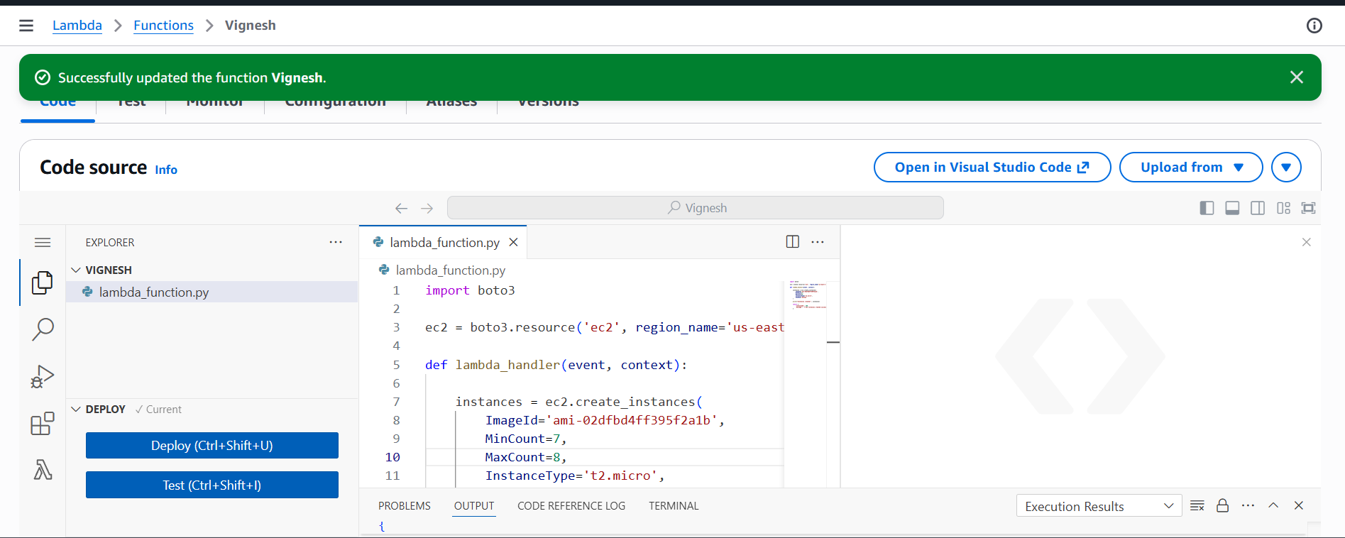

Step 6 — Test Lambda
- Click Test
- Create new event
Event JSON:
{}
Click Test again.
Lambda will run and create 7 EC2 instances.
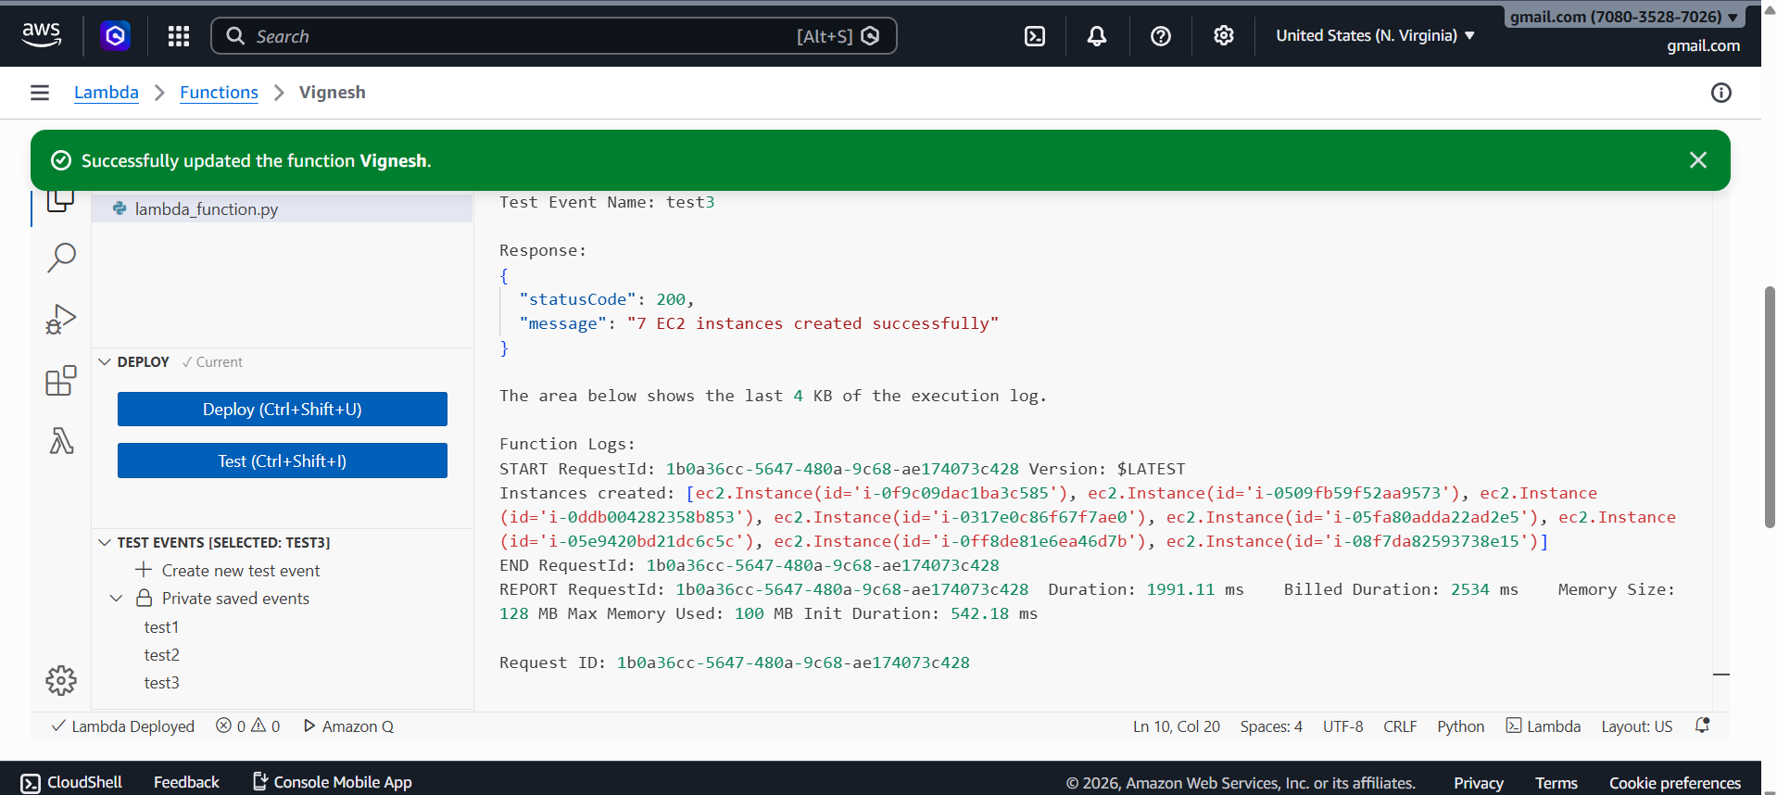

Step 7 — Verify EC2 Instances
- Go to EC2 Dashboard
- Click Instances
- You should see 7 new instances running.

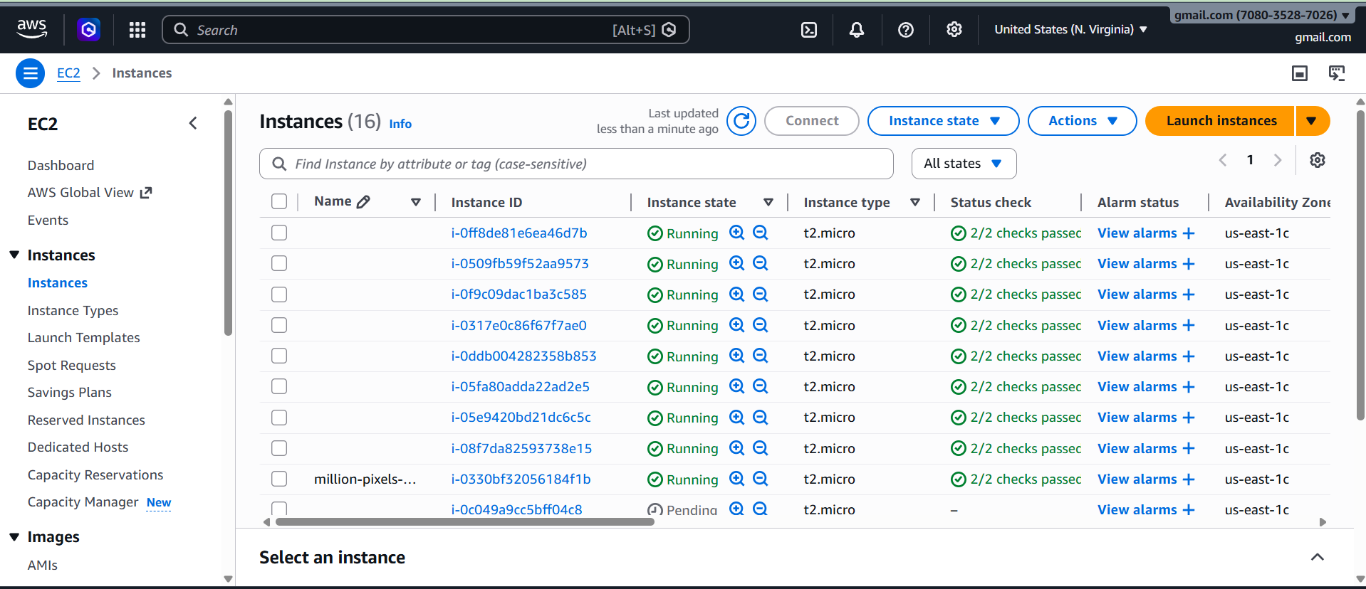

Final Working Architecture
User
↓
AWS Lambda
↓
Python Boto3 Code
↓
EC2 RunInstances API
↓
EC2 Instances Created

